Advanced genetics

Assessment Statements
- Explain the inheritance rules for human blood groups
- Define homozygous, heterozygous and carrier
- Analyze a pedigree and conclude the inheritance patterns behind it (dominant, recessive, intermediate)

Inheritance of blood groups
There are 4 phenotypes, the blood groups A, B, AB and 0. Antigens (surface characteristics) are formed on the red blood cells. These can be of type A or type B. Blood groups A and B have the corresponding antigens. Blood group AB has both, blood group 0 has none of these antigens.
Blood groups are determined by a gene with three alleles: I^{A}, I^{B} and i.
I^{A} is codominant to I^{B}
I^{A} and I^{B} are both dominant to i
Write down the genotypes for the following possible phenotypes:
A I^{A}I^{A} and I^{A}i
B I^{B}I^{B} and I^{B}i
AB I^{A}I^{B}
0 ii
A child has blood group B and the father blood group 0. Which blood group does the mother have?
She has B or AB.

Determine your own blood group
- Take a microscope slide and place a small drop each of anti-A, anti-B and rhesus solution (anti-D) on it.
- Add a drop of blood next to each drop of indicator.
- Mix one drop of blood with one drop of indicator. Always use a new toothpick. The indicator solutions must not mix. Do not place toothpicks on the table but dispose of them directly in the bottle.
- Observe where it agglutinates and where it does not, wait a few seconds.
- Find out your blood group by thinking about it. Check it with the illustration in the ppt.
- Dispose of your slide in the bottle.

My blood group is ________

Technical terms
homozygous = both alleles are the same, e.g., ww
heterozygous = the two alleles are different, e.g., Pw
carrier = an individual who carries a hidden allele, e.g. I^{A}i has blood group A but carries the allele for blood group 0

Pedigree analysis
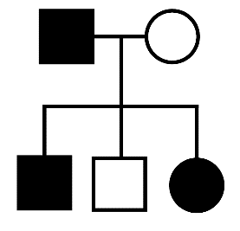
Each line represents a generation. Male is shown as a square, female as a circle. Filled-in shapes indicate that the observed factor is visible. This can be a hereditary disease, but also harmlessly a certain eye color.
If brown eyes are observed in this example, then a father with brown eyes has three children with a mother with blue eyes. One son has blue eyes, the daughter and another son have brown eyes.
To analyze the pedigree, it is helpful if we write down the alleles. Here B stands for brown, and b for blue:
Bb
bb
Bb
Bb
bb


Each child always receives one allele from the mother and one from the father. Therefore, the father must be Bb and not BB.

How to analyze a pedigree
If there are only two possible phenotypes, the inheritance is dominant-recessive. If there are three phenotypes, the inheritance is intermediate.
Parents without the phenotype and children with the phenotype are only found in recessive inheritance:
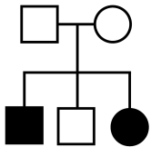
Both parents with the phenotype and no children with the phenotypes are only found with dominant inheritance:
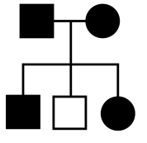
To find the inheritance rule, we must formulate a hypothesis and test it with the given phylogenetic tree. Especially with small pedigrees, it is sometimes not possible to be sure the trait is dominantly or recessively inherited.
However, it is never possible for a factor to be both dominant and recessive, or to change over the generations.

Tasks

Pedigree 1 Pedigree 2

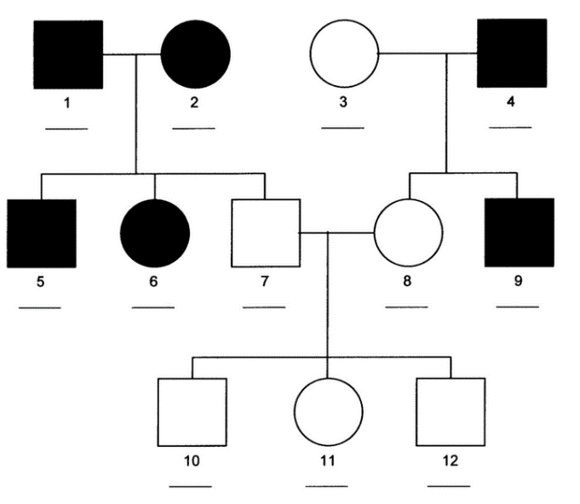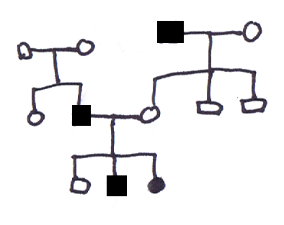

The solution can be found on the last page of the pptx.
More trees can be created at https://pedana.biologie.uni-due.de/

Used Tools and References
deepL: support with translation of own German texts
- Clegg, C. J. (2023). Biology for the IB diploma. (3rd edition). Hodder Education.
- Reece, J. B. et al. (2021). Campbell Biology. (12th edition). Pearson Education.
- https://slideplayer.com/slide/10952045/

CC BY 4.0 DEED for contents created by Daniel Margadant
For other sources (e.g., figures) please consider © of corresponding reference

